**How to play Zeitgeist.**  
This guide is meant to be an introduction to the Zeitgeist Card Game for new players.

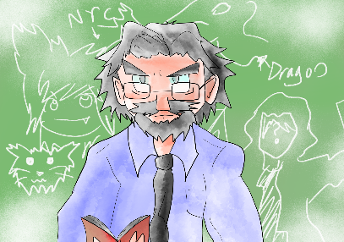**BASIC TOPICS**  
1.- Types of Cards.  
2.- Field.  
3.- Actions.  
4.- Battle system.  
5.- Parts of the turn.  
**ADVANCED TOPICS**  
1.- Keywords.  
2.- Terminology.  
  
**BASIC TOPICS**  
**1.- Types of Cards.**  
(Being, Zeitgeist, Hazard, Zeal)  
  
As of Zeitgeist’s first set there are four types of cards.  
  
**Zeal cards.**ANY card in the game may be played as a Zeal by putting it from your hand onto any of the six spots in the **Zeal Zone**. During your turn, you may put only one card into the zeal zone. Once a card has been put in the Zeal zone, it is no longer considered a being, hazard or zeitgeist card, it loses all the cards abilities, except for **Zealbond** abilities and becomes a Zeal card which is a material (that means that they stay on the field), which produces zeal of the card’s color when **rotated**.

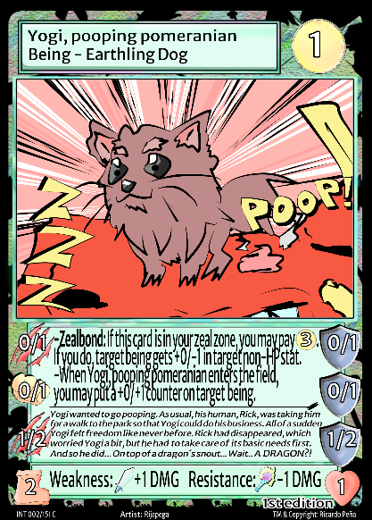Pink cards produce wind Zeal.   
Green cards produce earth Zeal.  
Red cards produce fire Zeal.  
Blue cards produce water Zeal.  
Black cards produce dark Zeal.  
  
Zeal is the main resource in the game. It is used to play the other three types of cards (Beings, Zeitgeist and Hazard), to **pay for effects**, to **attack** and **defend**.   
  
**Being cards.**Beings can **move**, **attack** and **defend**, be it your opponent’s being cards or your opponent itself.   
  
You may summon being cards during your turn. In order to play a Being card you have to pay its **Zeal cost** and can only be **summoned** in the **Summoning Zone** (Unless stated otherwise in the card). Once summoned, they are treated as **material** (that means that they stay on the field), and you can move them or attack with them the same turn they were summoned (Unless stated otherwise in the card).

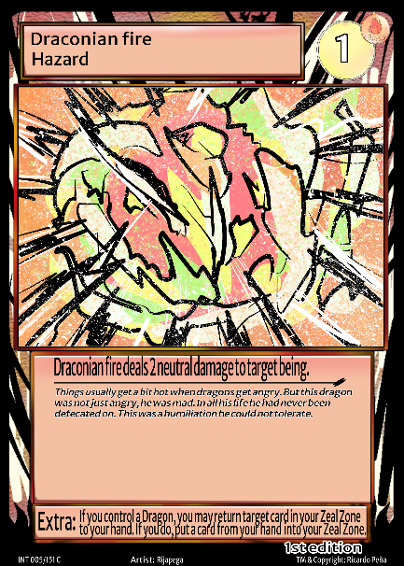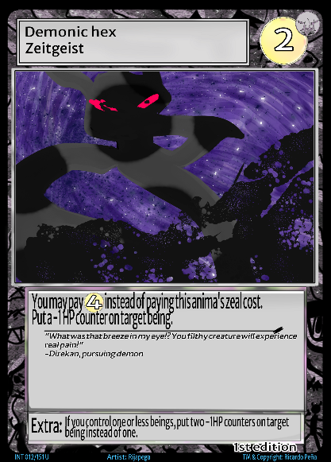**Zeitgeist cards.**Zeitgeist cards, unlike Zeal cards and being cards, are considered non-material (that means that they do not stay on the field). Also, you do not need to play them in the summoning zone or the zeal zone, there is no specific zone to play a Zeitgeist card. You just play them from your hand and their effects will be activated once the effect **resolves**.  
  
You may play Zeitgeist cards only during your turn (Unless stated otherwise in the card), by paying their Zeal cost. Once a Zeitgeist card’s effect is activated and resolves, Zeitgeist Cards are sent to the graveyard.  
  
**Hazard cards.**Hazard cards may be activated in the same way a Zeitgeist card is, but there is a key difference between Zeitgeist cards and Hazard cards. Hazard cards are the ONLY card type that you may put in the zeal zone face-down (You can also put if face-up like you’d normally do, in case you need a zeal from that color right away).  
  
A face-down Zeal card produces uncolored Zeal when rotated until it is face-up. In order for a Hazard card to be flipped face-up you have to activate it by paying its Zeal cost (e.g. you can’t just flip it face-up if you need that face-down Zeal card to produce colored Zeal). Once you pay a face-down Zeal card’s Zeal cost, it is flipped face-up and its effect is activated. Then the card stays on the field as a face-up Zeal.  
  
 Hazard cards may be activated starting from the turn after they were set in the Zeal zone (but they can be rotated the same turn they were put there).   
  
  
Before moving on, let’s examine the structure of a Being card, if you understand how a Being card is used you understand the game.   
  
First we will take a look at the stats that EVERY card shares, and then we will check the stats that are unique to being cards.  
  
The card’s name is in the rectangle located in the left top part of the card. Below the card’s name is the card type (which can be being, zeitgeist or hazard) and then its subtypes in the case of beings.  
  
To the right of that rectangle is the Zeal cost, in the case of this card, its Zeal cost is only 2 which means you can pay its zeal cost with any kind of zeal as it doesn’t require any specific type.   
  
Below that is the art of the card, which is also something all cards have. What would be of a card game without the pretty art, right?  
  
Below the card’s art, inside a big rectangle all cards have some sort of effects and flavor text.  
  
The last stat that all cards share is the information on the lower part of the cards, that is the set/number/rarity, the artist and the cards copyright. This information isn’t really that important, but you can differentiate immediately the rarity of a card (and thus, its power, generally speaking) by looking at the color of the text.  
Common cards have white text and are represented by “C”.  
Uncommon cards have blue text and are represented by “UC”.  
Rare cards have yellow text and are represented by “R”.  
Super Rare cards have red text and are represented by “SR”.  
Ultra Rare cards have purple text and are represented by “UR”.  
  
Now let’s take a look at the information that is only present in being cards, which is the icons in the lower part of the card.  
  
You probably noticed a boot on the lower left part of the card, that is used to represent the number of **blocks** that that being may move each turn.  
  
As for the heart in the lower right part of the card, it represents the **HP** of the being. Once a Being card’s **HP** reaches 0 it is sent to the **graveyard**.  
  
There is a large rectangle between those two stats, that rectangle has two stats which are weakness and resistance. There are different types of attacks in Zeitgeist, and beings may be weak or resistant to those types of attacks.

Having a weakness means that that being will take +1 damage from the type of attack shown right to the word weakness.   
Having a resistance means that that being will take -1 damage from the type of attack shown right to the word resistance.  
  
Above that, in the rectangle in the middle you can see that there are some words in bold, that indicates that there are keywords. Not all abilities are keyworded, but in this case this card has two different abilities, **Meditate** and **Zealbond**.  
  
There is an advanced level part for this tutorial which covers keywords, but for now we will quickly explain these two:  
Meditate basically means, “If this being didn’t move or attack (x) happens”. It’s a keyword assigned to more control/slow archtypes.  
Zealbond are abilities that can only be activated if that card is in the Zeal Zone (So, only if the card is a Zeal card, not a being card).  
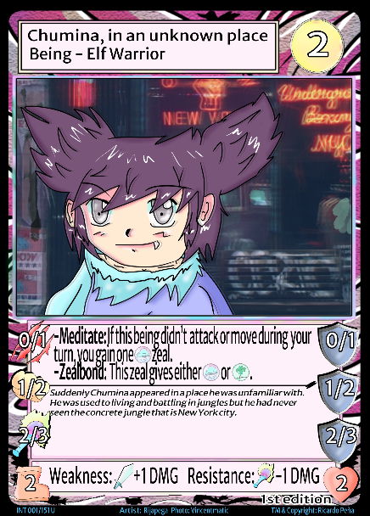  
Now let’s move on to all those icons on the left and right part of the card. The ones on the left are attack options, the ones on the right are defense options.  
  
Being cards have three different attack options (on the left part of the card). Each attack option has two numbers which are its Zeal cost (on the left) and the attack, which is the damage that will be dealt (on the right). Usually the first attack costs 0 to use, so in Chumina, in an unknown place’s example its first attack costs 0 to activate and it does 1 **SCRATCH** damage. Its second attack costs 1 to activate and does 2 **PUNCH** damage. Its third attack costs 2 to activate and does 3 **MAGIC** damage.   
  
 (Remember that each being has weakness and resistances, so planning what attack to use is vital in the game).  
  
Defenses are represented by shields and also each being has three different defense options (on the right part of the card).  
Each defense option has two numbers which are its Zeal cost (on the left) and the defense, which is the damage it will block (on the right). Usually the first attack costs 0 to use, so in Chumina, in an unknown place’s example its first defense costs 0 to activate and it blocks 1 damage. Its second defense costs 1 to activate and blocks 2 damage. Its third defense costs 2 to activate and blocks 3 damage.   
 **2.- Field.**  
Zeitgeist is played on 9 x 7 board. Each square is called a **slot**. Most slots are normal slots, but there are 3 special zones. **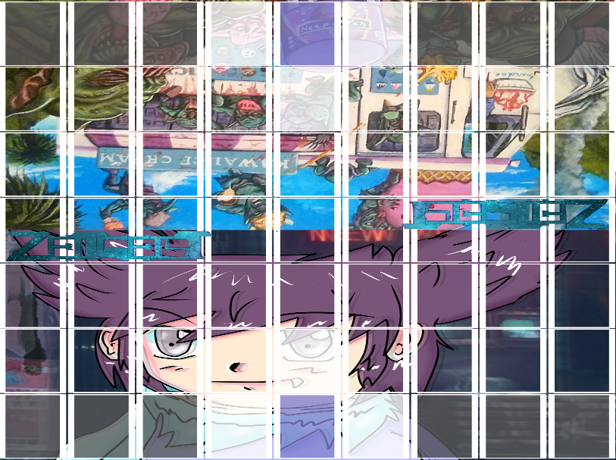  
  
Paramount Zone**This is the slot where your deck goes, it is located in the middle of the first line of your side of the field (The 4th slot, in this image it’s shown in blue). Your objective is to get to your opponent’s Paramount Zone and attack them until their life, which starts at 10 life points goes to 0.  
  
**Summoning Zone**The white slot in the image shown. These are the slots where you can summon (play) your being cards. There are 3 summoning zones, two are located next to your Paramount Zone, the other one is in front of it. You can’t summon in any slot in the summoning zone that is being occupied by a being (Be it your own or your opponent’s) so some strategies to win the game include occupying your opponent’s summoning zones. **Zeal Zone**The black slots in the image. The remaining six slots in the first line on the side of your field are your Zeal Zone, where you may put any type of card (Being, Zeitgeist or Hazard) there and it will become a Zeal card. Since there are only six slots that make the Zeal zone, the maximum number of possible Zeal cards you can have is six.  
You may not place a zeal card in a zeal zone if occupied by a being. Once a card has been put in the zeal zone it becomes a zeal and nothing can be put on top of that card.  **Graveyard**  
This is a zone that exists outside of the field. This is where you send discarded cards, Zeitgeist cards and Hazards cards that you played from your hand and Being cards whose HP got to 0.

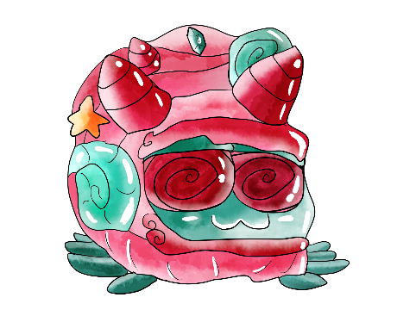**3.- Actions**  
**Summoning:**To summon a being you pay its Zeal cost. Once you do, you put it   
on any of the three slots in your Summoning Zone.   
 **Playing:**You play Zeitgeist and Hazard cards in the same fashion you would summon a being, by paying their Zeal cost. Once you do, their effects activate and they are sent to the graveyard (Unless you played a Hazard card which was in your Zeal zone, in that case the card is just flipped, the effect activates and now stays in the Zeal Zone face-up).  
 **Putting a card in your Zeal Zone:**Any type of card may be put in the Zeal Zone, once you do that, cards are no longer considered a beings, zeitgeists or hazards and are now considered Zeal Cards.  
  
**Pay a cost:**You pay a cost usually to activate an effect, attack, defense or to summon a being or play a Zeitgeist or Hazard card.  
Most costs are paid with the game’s most used resource which is Zeal, in order to do so you rotate cards in your Zeal Zone 90**° until you have sufficient Zeal to pay for that cost.  
There are other type costs which are way less frequent such as paying life, rotating your cards, discarding a card, etc  
Basically you need to pay that cost in order for an effect to activate, otherwise the effect doesn’t activate.**  
**Rotate:**Rotating means turning your card certain degrees to indicate a certain action has been performed.There are three types of rotation, 45**°,** 90**° and 135°.  
Rotating your card** 45**° indicates that that card has been moved during your turn.  
Rotating your card** 90**° indicates that that card has attacked during your turn OR in the case of a Zeal card, that that card has been used to produce Zeal.**90**° rotation may be represented by the icon.  
Rotating your card** 135**° indicates that that card has defended once during your opponent’s turn.**  
**Move:**  
You may move a being only during your turn (unless stated otherwise) and up to the number of slots stated in the move stat of your being (Which is the boot on the lower left part of the card). Once you move a being, you rotate it 45**°** to indicate that being was already moved. You may attack with your being once it has moved (but it is not necessary for a being to move to declare an attack), however you CAN NOT move your being after it has attacked.  
  
  
**Flip:**To flip a card is to change a card from a face-down to a face-up position and vice versa. Currently only Hazard cards may be flipped, only from face-down to face-up position. (They can not be flipped face-down again).  
   
**Attack:**Once you are close enough to an opponent’s being (depending if your attack is short-ranged which means you must be orthogonally positioned from your being, or long-ranged which means your being must be one slot away from your opponent’s being) you may declare an attack. Each being has 3 attack options, you choose one of the three, pay its Zeal cost (If unable to do so, you can not choose that attack) and **rotate attacking being** 90**° to indicate that it has attacked declared an attack**.  
  
Once an attack has been declared, your opponent may choose to defend, or respond with an effect, a Hazard card or a card with **Trick**.  
  
**Defend:**Once a being has become the target of an attack, you may defend from that attack (You may also choose not to defend, and let the attack deal all the damage).  
To defend you choose between one of the three defense options of attacked being, pay its zeal cost (If unable to do so, you can not choose that defense) and you **rotate defending being card** 135**° to indicate that that card has defended once during your opponent’s turn.  
  
(Depending on the format you are playing under each being may only defend once per turn OR it may defend once per defense option per turn.)  
  
After you have declared a defense,** your opponent may choose to respond with an effect, a Hazard card or a card with **Trick**.  
  
**4.- Battle system  
  
Two main formats to play**Previously it was mentioned that there are two formats in which you may play Zeitgeist. These two formats are differentiated by one simple mechanic change, that is the number of times defense is used in both formats.  
  
Cards that were very powerful in one format are not so much in another, and viceversa. The meta will likely be completely different between these two formats, all these with that simple change.  
  
The name of the two formats is:  
  
-**MonoShield format** in which each being may **only defend once per turn.**-**PoliShield format in which each being may defend once per defense option per turn. (So a being may defend up to three times in each turn, if you can pay its 3 different defense options).**  
Generally speaking, PoliShield is a longer format, it plays more like a board game than a card game, games lasting around 1 hour at least, and up to 2 and half hours during our gameplays. But once you get used to the game PoliShield format games usually last around an hour.  
  
MonoShield, which is the format which we have chosen as the basis of the game is quicker in nature, games lasting anywhere between 10 to 30 minutes.  
  
It is our belief that this simple change will give players countless hours of fun and invite you to play them and choose your favorite.  
Nothing else is different between these two formats, every other mechanic other than defense remains exactly the same, but changing formats really feels like playing a completely different game.  
   
**Different types of attacks**There are 7 different types of attacks which are Punch, Sword, Scratch, Arrow, Magic, Elemental and Psychic.  
  
Attacks have different properties attributed to them, as there are physical attacks (Scratch, Sword, Punch and Arrow) and Special attacks (Magic, Elemental and Psychic).  
  
In this first edition of Zeitgeist knowing which attacks is Physical or Special is not important as no cards interact with that attribute BUT it is very important to know which attacks are long-ranged or short-ranged.  
  
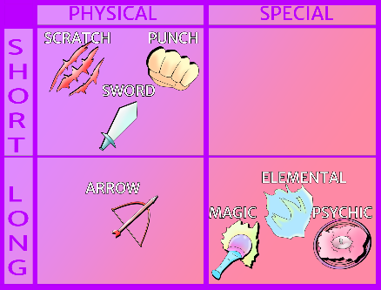Short-ranged attacks are attacks that may only be declared if you being is orthogonally to your opponent’s being (That is, if it is next to, below or above your opponent’s being). Short-ranged attacks are Scratch, Sword and Punch.  
  
Long-ranged attacks are attacks that may only be declared if you being is one slot apart from your opponent’s being. Long-ranged attacks are Arrow, Magic, Elemental and Psychic.  
  
In this example Playful Dragon’s first attack which is a Scratch attack (A short-ranged attack) 0/1 could only target beings that would be in the blue slots.  
Playful Dragon’s 2nd and 3rd attacks are Elemental attacks, which are long-ranged, which means that in order to attack with them your opponent’s being must be one slot apart from your attacking being. The yellow slots are the only ones in which you could target an opponent’s being with Playful Dragon’s 2nd or 3rd attack.

**Calculating damage**After an attack has been declared and a defense has been chosen (or not) and any other effects have been activated (or not), we proceed to calculate damage.  
This is where weaknesses and resistances come into play.  
If defending being is weak to the attack that was used it receives +1 Damage.   
If defending being is resistant to the attack that was used it receives -1 Damage.  
The formula to calculate damage is as follows:  
  
Attack-Defense-Resistance+Weakness=Damage dealt  
  
After damage has calculated Damage dealt is subtracted from defending being’s HP. You do so by putting -1 HP counters on defending being equal to the Damage dealt. Each -1 HP counter diminishes the beings HP by 1, and if being’s HP is 0 or lower it is sent to the graveyard.   
  
-1 HP counter stays on beings, even if turn pass (So damage isn’t recovered every turn).  
  
**5.- Parts of the turn**You start the game with 7 cards and 10 life points.  
  
**Beginning Phase**  
This happens at the beginning of your turn.  
**-Unrotate step:** All cards that are rotated are returned to their original unrotated state.  
**-Draw step:** You draw a card, unless it’s the first turn of the game.  
  
**Main Phase**This happens once you have drawn your card. You can do the following actions ONLY during your main phase (Unless stated otherwise):  
**-Put a card in your zeal zone:** You may perform this action only once per turn.  
**-Summon a being card.**  
**-Play a Zeitgeist or Hazard card.  
-Move a being:** You may perform this action during your turn once per turn per being. You place your being in a slot that is within distance equal to or less than that being’s movement and once you do you rotate that being 45**° to indicate it has moved that turn.**  
**-Attack with a being:** You choose one of your being’s 3 attack options, pay its zeal cost and rotate your attacking being 90**° to indicate it has attacked**.  
If you declare an attack you start a battle phase.  
**-Activate effects (Unless stated otherwise).**  
  
**Battle phase**  
**-Attack step:** You choose one of the three attacks to target opponent’s being, pays its zeal cost and rotate your attacking being 90**° to indicate it has attacked**. Opponent may respond with a hazard card, a card with trick or by defending (or not), then we proceed to the Defense step.  
**-Defense step:** Opponent chooses one of its being’s 3 defenses (or not), pays its zeal cost and rotate defending being 135 **to indicate it has defended**. You or your opponent may respond with a hazard card, a card with trick or by defending (or not), then we proceed to the Damage calculation step.  
**-Damage calculation step:** Damage is calculated by using this formula:  
**Attack-Defense-Resistance+Weakness=Damage dealt**After damage has calculated Damage dealt is subtracted from defending being’s HP by putting -1 HP counters equal to the Damage Dealt. If that being’s HP is 0 or less it is sent to the graveyard.  
  
Once a battle phase is over you return to your main phase, you may perform any other number of actions in your main phase until you are satisfied and pass turn to your opponent.  
  
**Ending Phase** “Until end of turn” effects end.

**ADVANCED TOPICS**  
**1.- Keywords**

|  |
| --- |
| **Trick:**  This card may be played at any time. |

|  |
| --- |
| **Back-up:**  This being may be played in an adjecent orthogonal slot (up, low, left or  right) to target being you control. |

|  |
| --- |
| **Manipulate:**  At the beginning of turn, you may choose target unrotated being you  control, if you do, (X) happens until end of turn. That being is not able to move or attack this turn. |

|  |
| --- |
| **Retreat:**  This creature can move at the beginning of your opponent’s turn. |

|  |
| --- |
| **Gravengeance:**  When this creature dies [x] happens. |

|  |
| --- |
| **Meditate:** At the beginning of turn,If this creature didn’t attack or move during your turn you gain [x]. |

|  |
| --- |
| **Zealbond:**  If this card is in your zeal zone you can do [x]. |

|  |
| --- |
| **Heal:**  Do [x] and target creature recovers [x] HP. (It “recovers” HP, not  gain). (It doesn’t heal itself). |

|  |
| --- |
| **Monomyth:** Every time this Being attacks [x] happens. |

|  |
| --- |
| **Zeitguard:** This material is not affected by opponent’s targeted effects. |

|  |
| --- |
| **Solitude:** If this is the only being you control [x] happens. |

|  |
| --- |
| **Bond of unity:**  At the beginning of (your/each) turn, if there is a being you control  in an adjecent orthogonal slot to this being [x] happens. |

|  |
| --- |
| **Kinship:**  For each [x] other being under your control [x] happens. |

|  |
| --- |
| **Mount:**  Active if, at the start of your turn, a material with Mount is next to one without Mount. If you do, put both materials in the same slot of the field. These materials can move the sum of their movements. Only the material with Mount may attack, use its abilities or be a target. You must dismount the materials before the end step of your turn. When you do, both materials are separated. When dismounting, the material with Mount remains in the landing slot of the field, and the other material must be put in an adjecent orthogonal slot to the material with Mount. Dismounted material can’t attack this turn. |

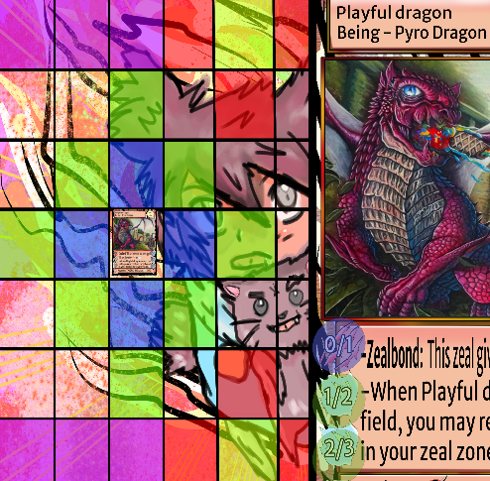**2.- Terminology**  
**Material:**A material is a card that remains on the field indefinitely. Usually Beings and Zeal are considered Material.  
  
**Non-Material:**A non-material is a card that, once used, is sent to the graveyard. Usually Zeitgeist and Hazard cards (Played from the hand) are considered Non-Material.  
  
**Orthogonally:**It means that a card is next to or in front or behind another card (Basically in a “t” shape).

In this example the ortoghonal zones to Playful Dragon are marked in blue. This means that its first attack, which is a short-ranged attack would be able to target beings in the blue slots, which are orthogonal to Playful Dragon.   
  
**Activate:**Once a card is “played” its activation starts, the opponent may then do an action to respond to yours, if they do so then their action activates and then resolves. If your opponent doesn’t answer to your card’s activation (Being played) then your card resolves and its effect happens or the being is summoned to the field. **Resolve:**Once a card’s effect resolves it means that it has been activated completely (Meaning that the opponent didn’t answer to it or the opponent’s answer resolved already).  
 **Neutral damage:**Damage not affected by weaknesses or resitances.  
**Inevitable damage:**   
Damage that can not be blocked.

**--------------------------------------------------------------------  
  
Changes in V1.1:  
  
Terminology changed, all instances of “block” to refer to squares in the field were changed to the correct in-game term which is “slot”.**